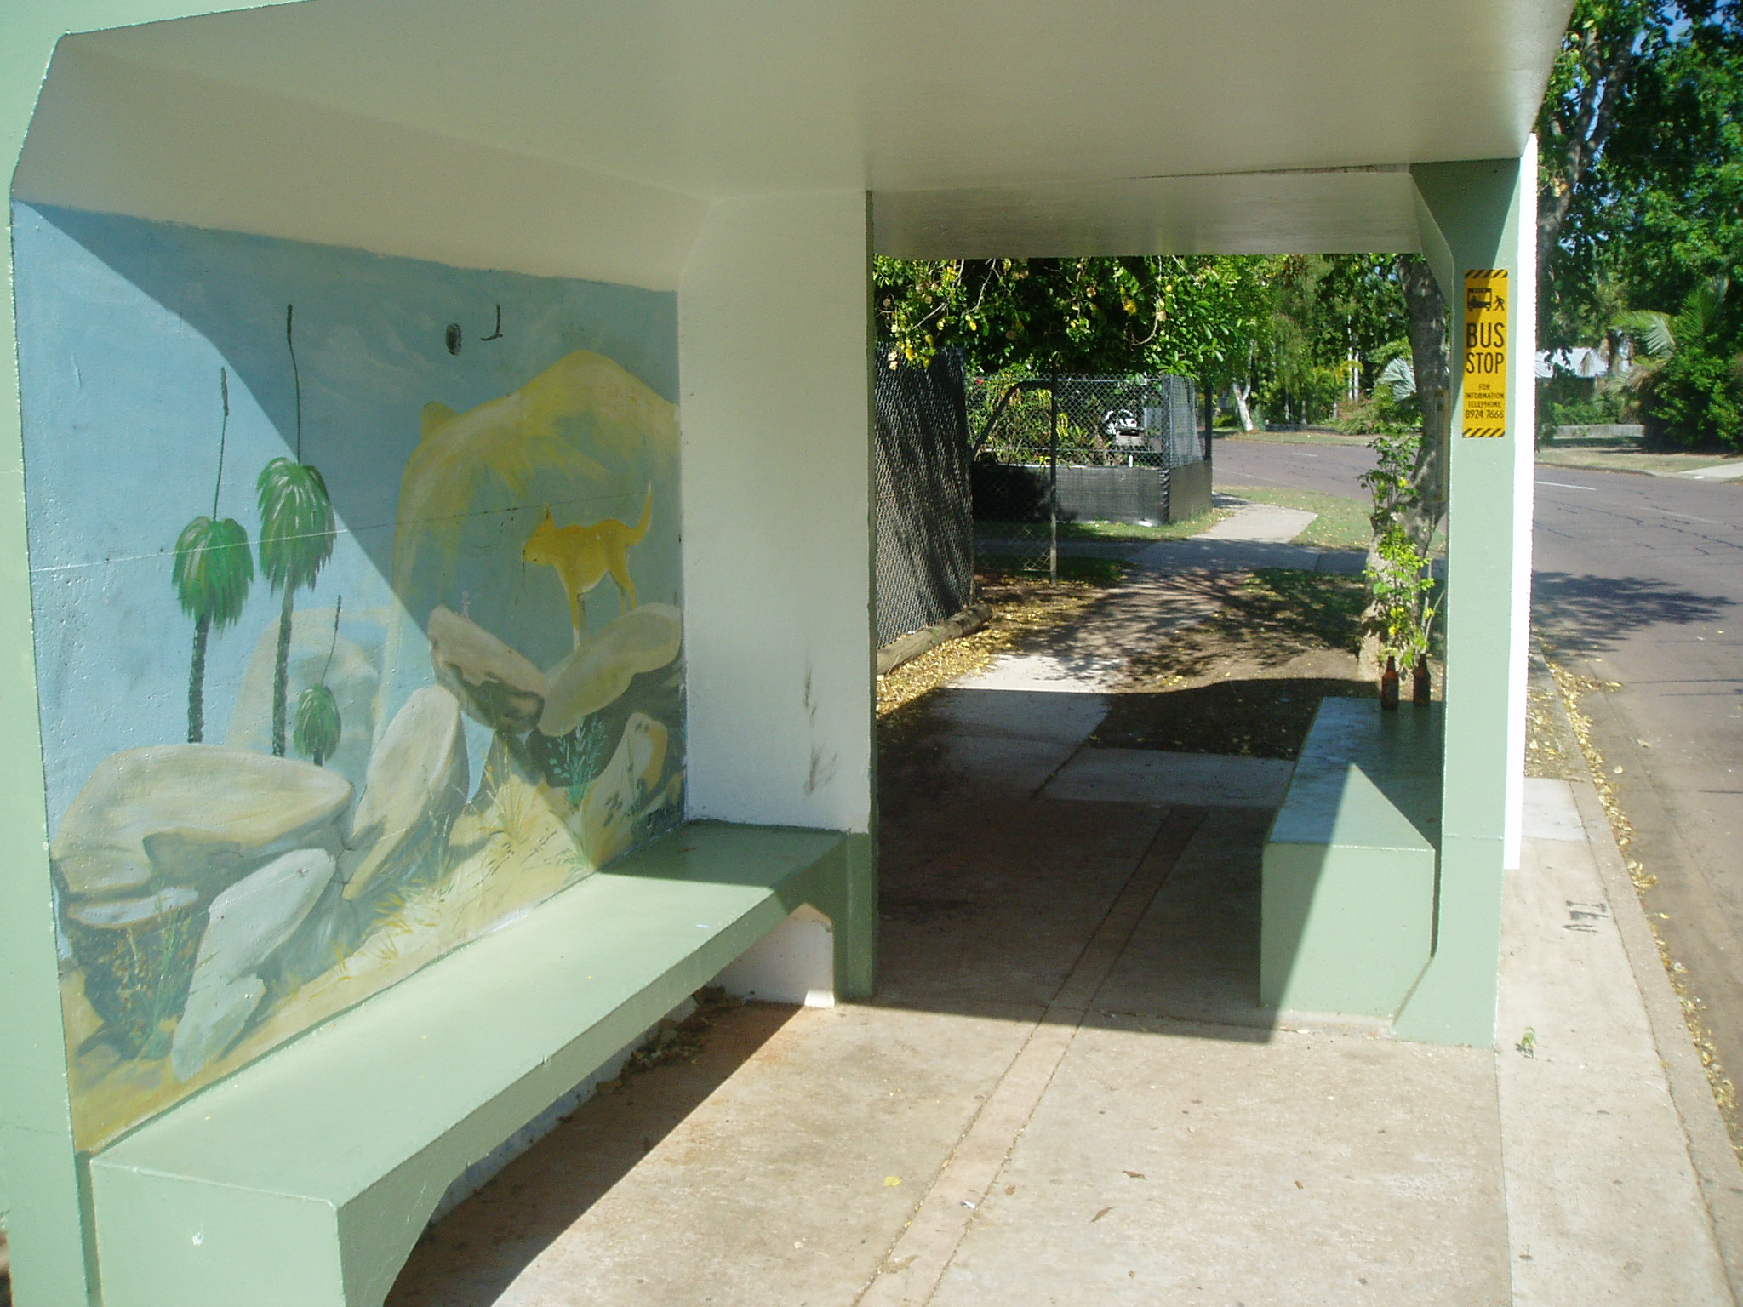
Above: Springhill St bus stop where Graham X met the two girls in May, 2003.
Below: The path from the bus stop to Anula School.
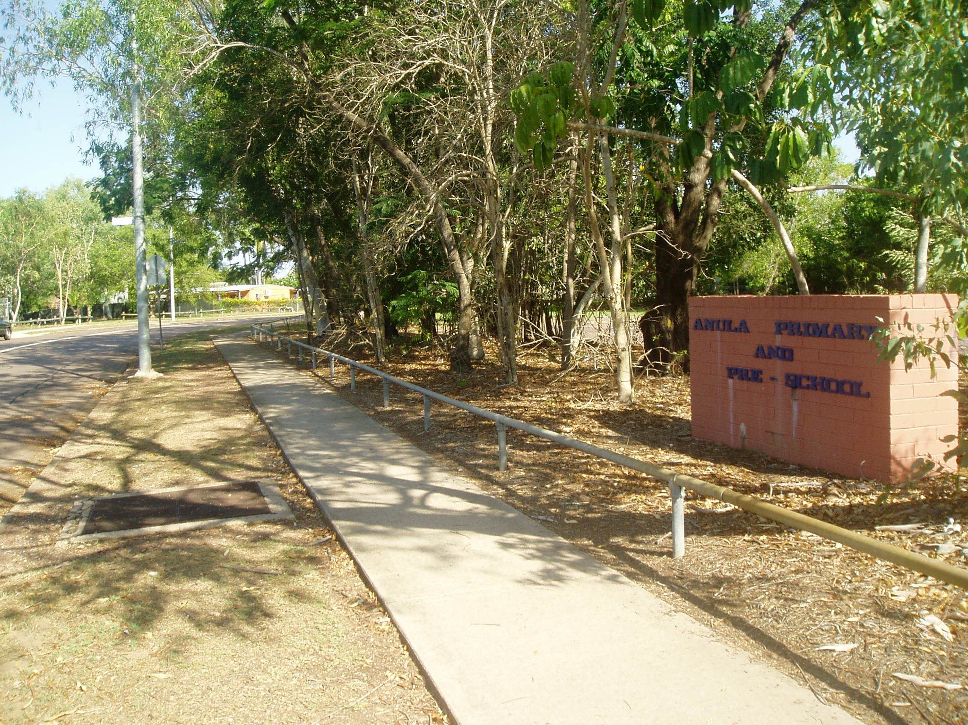
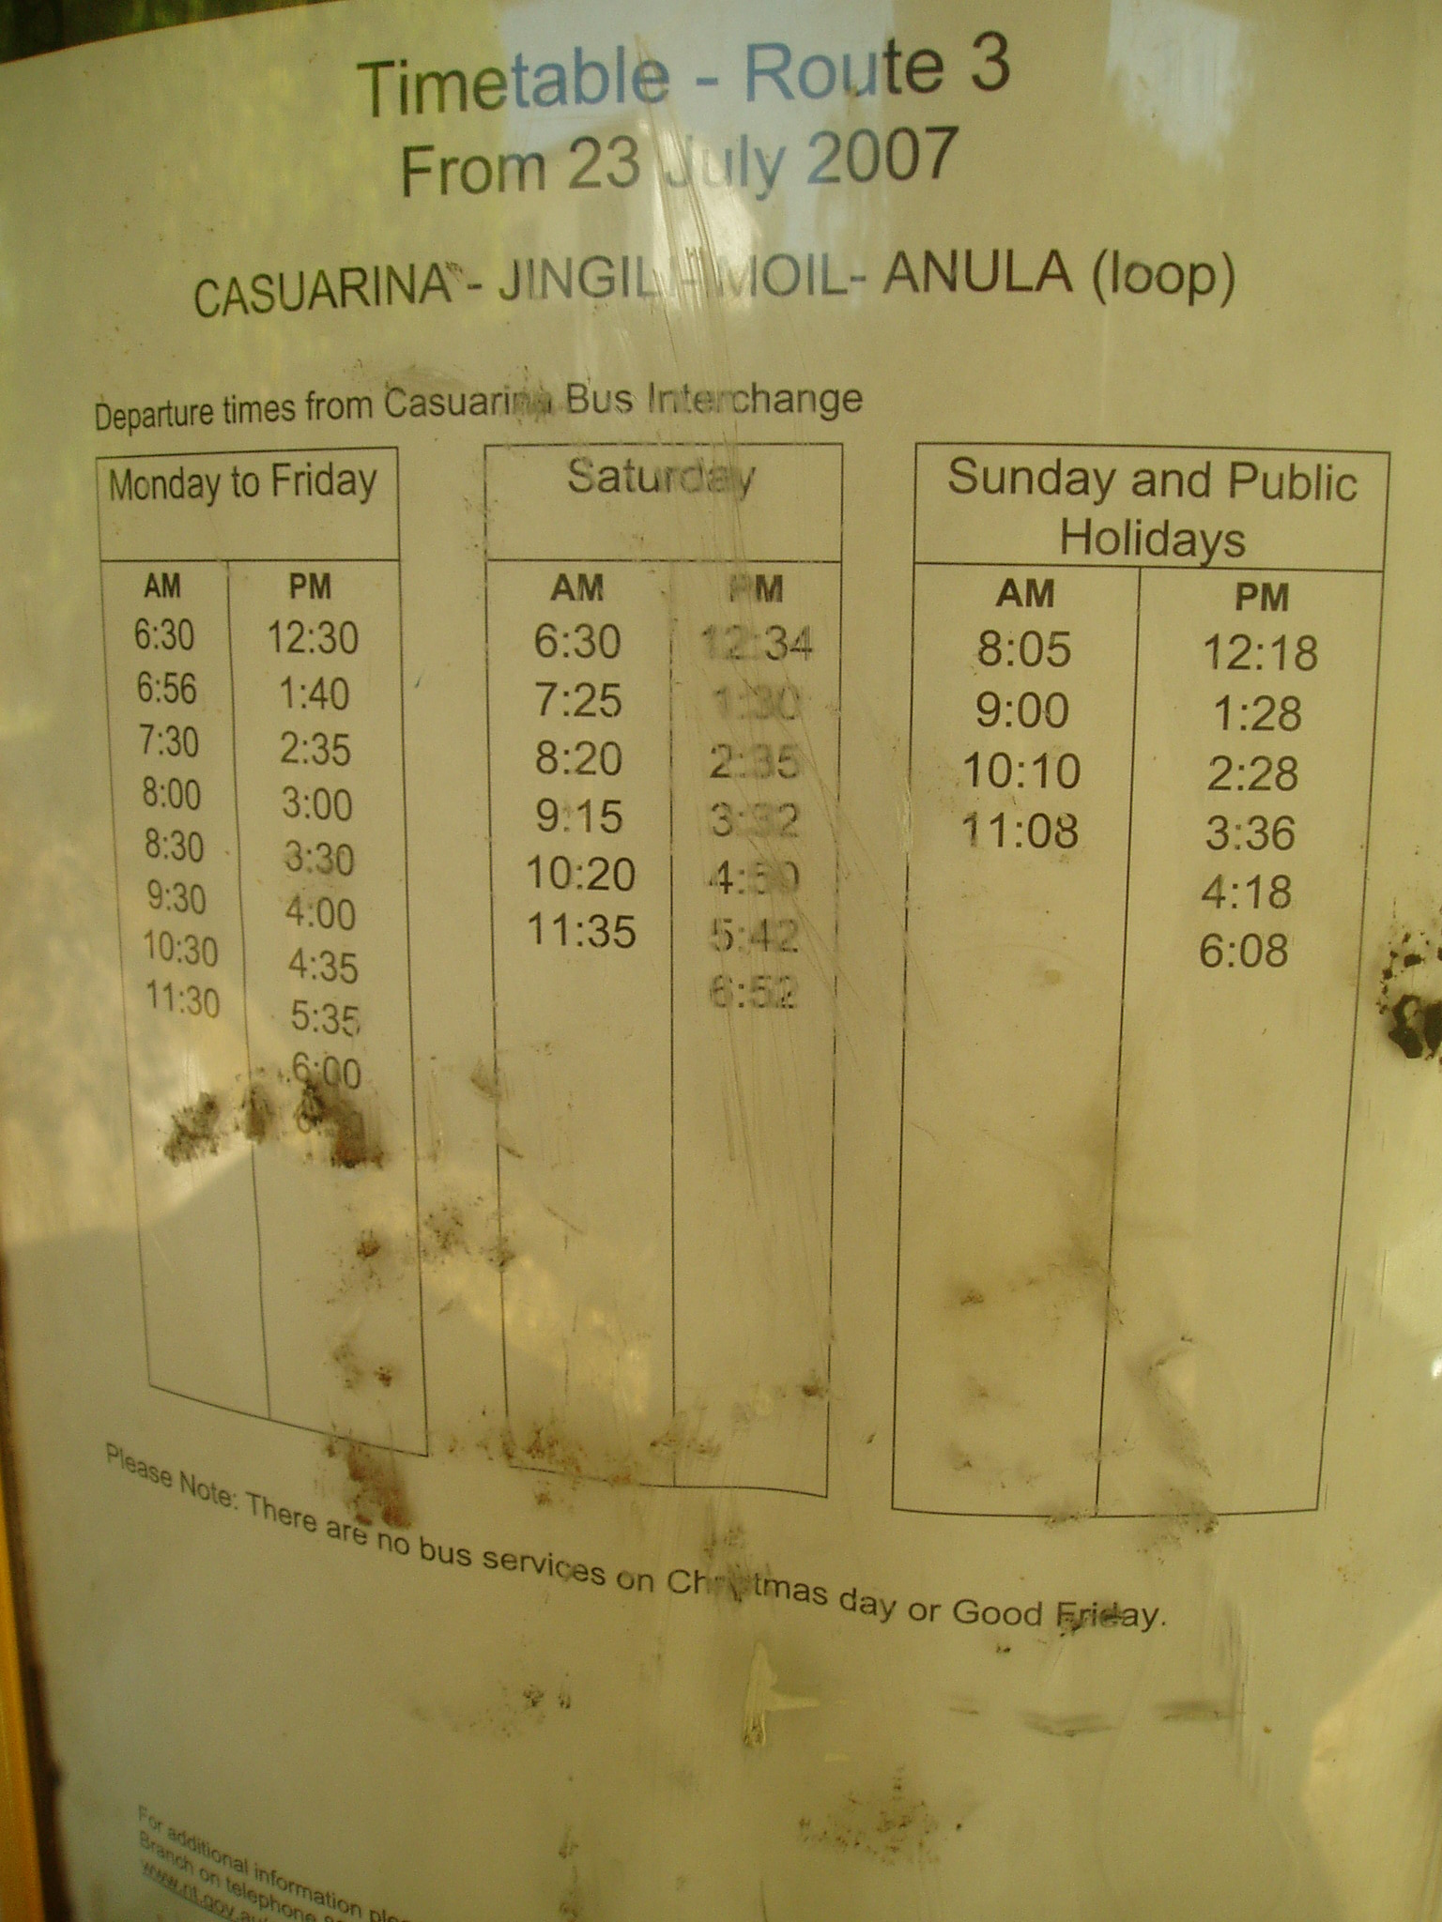
Above: Bus timetable on the Springhill St bus stop (some years later).
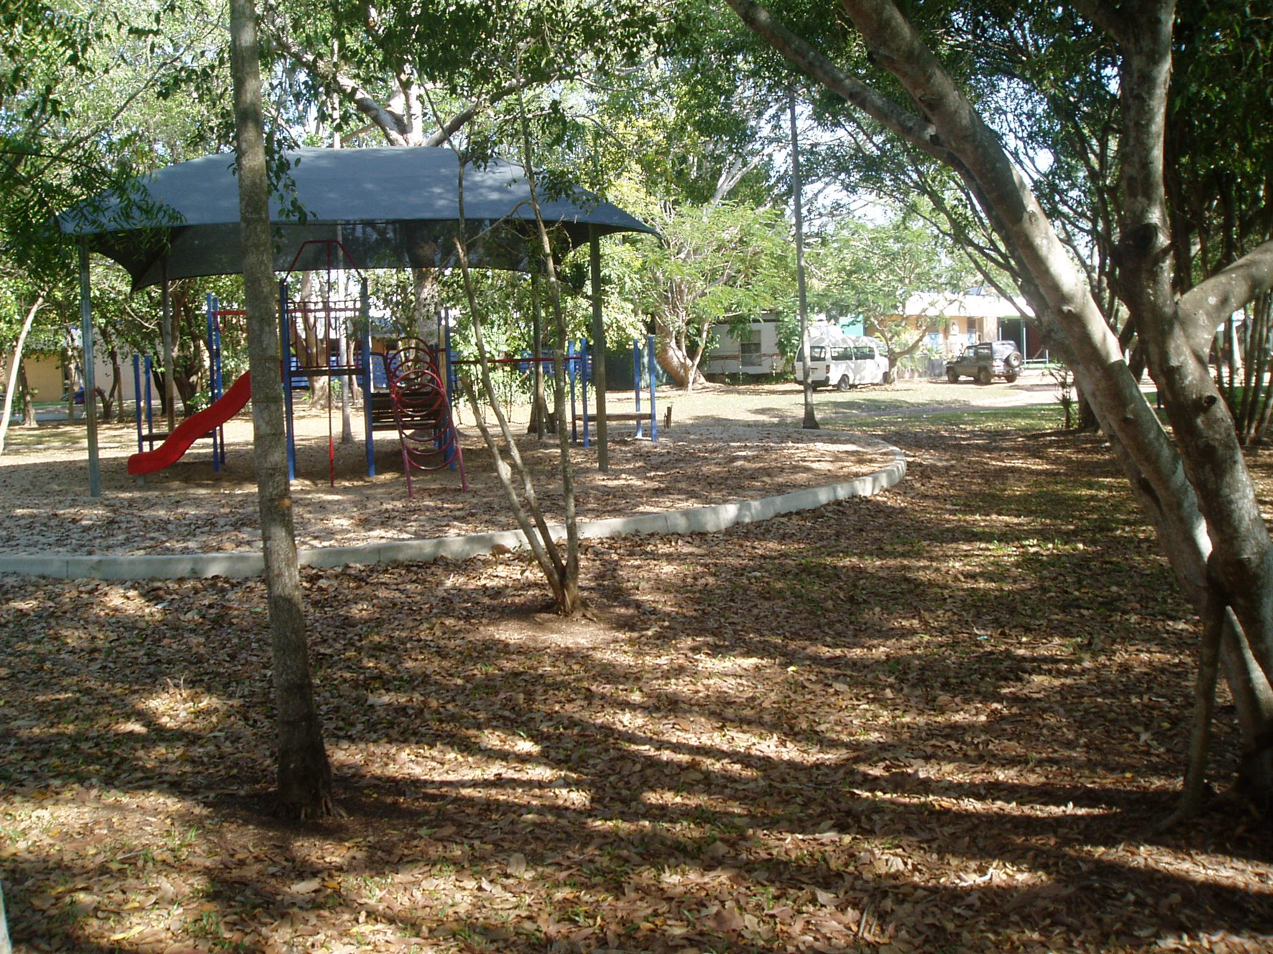
Above: School caretaker's caravan Anula School.
Below: Path through Anula School.
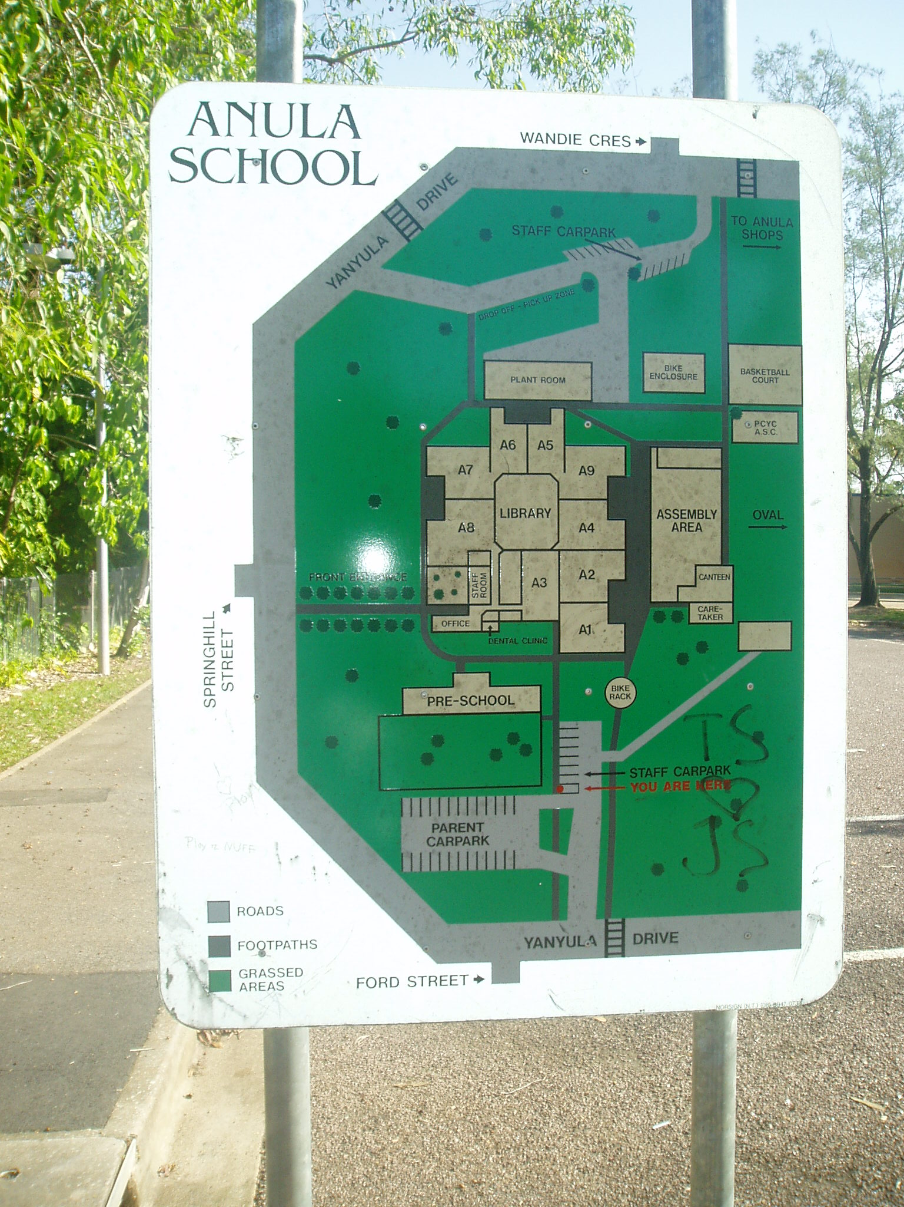
Above: Map of Anula School grounds and neighouring Streets.
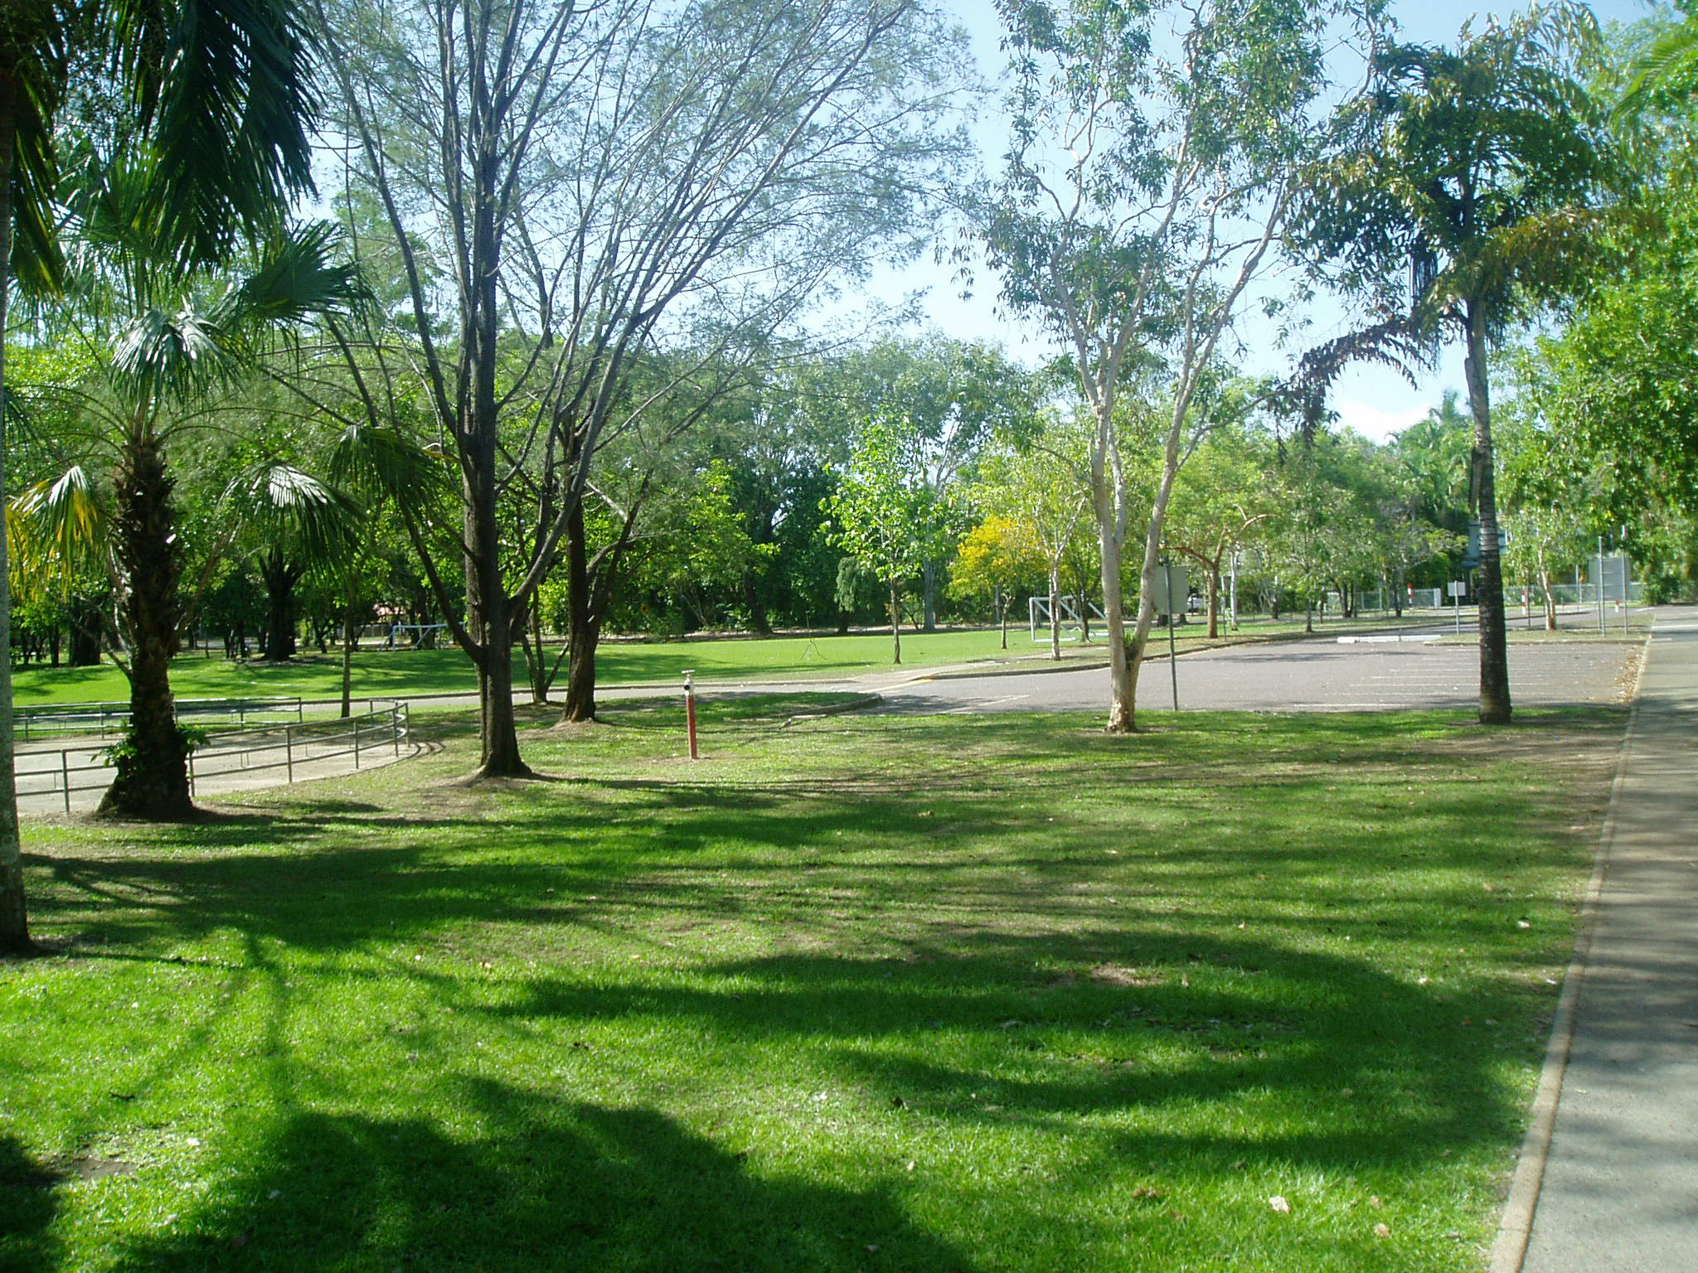
Above: View across school grounds to Yanyula Drive.
Below: Springhill St bus stop from Yanyula Drive.
